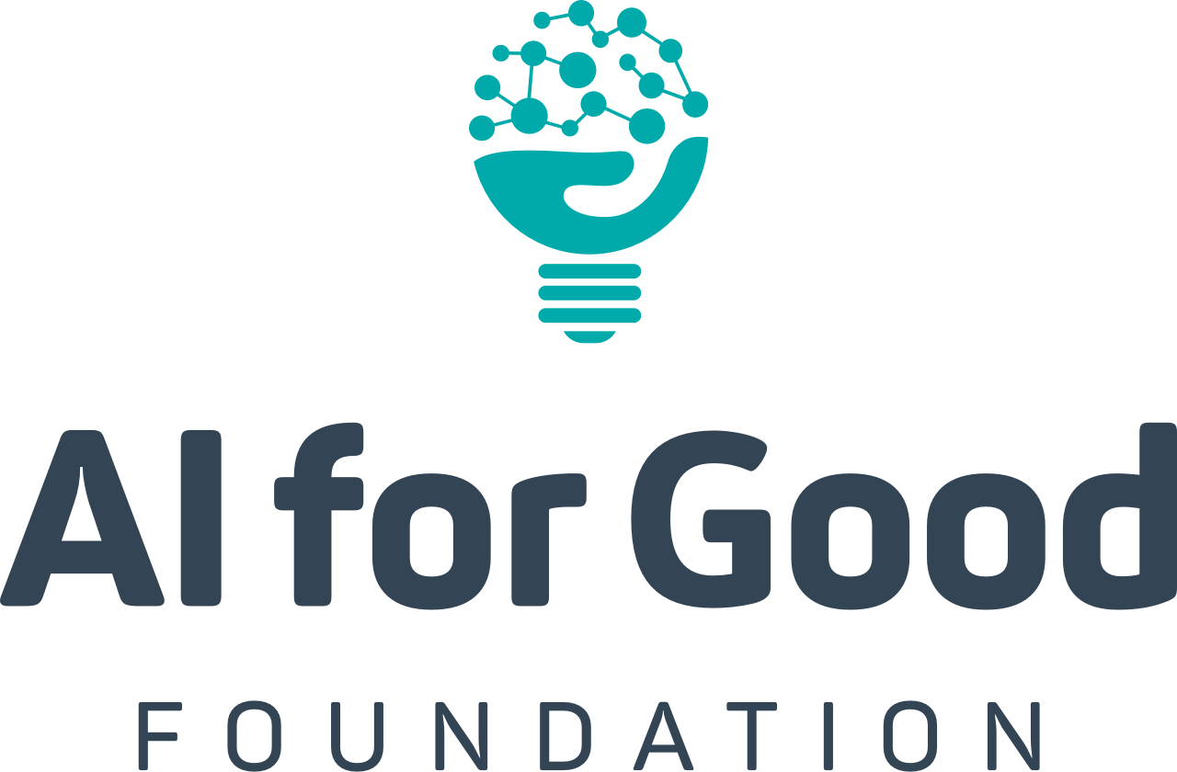

AI + SDG Launchpad
Core Syllabus
2 Semester

Course Overview
The Sustainable Development Goals are the rallying call of our generation. In an enormously complex and interconnected world, we have watched as some of our most fragile ecological structures have been driven to extremes; we have seen only marginal improvements in the delivery of basic literacy and numeracy; universal healthcare is a far-off aspiration, and half of our population participates in society as second class citizens. The acceleration of technology adoption has leveled some playing fields and widened others. Access to technology plays a role in the concentration of wealth and inequality and puts editorial news outlets on a level playing field with advertising networks and propaganda peddlers.
How should technology innovation (and its prodigal child—Artificial Intelligence) be leveraged to support a positive impact on these critical objectives? How do we research, design, debate, plan, and execute interventions that are both human and technological at heart? How do we engender resilient communities with bold plans to make them healthier, happier, and more sustainable? This course seeks to answer these questions

Course Objectives
The purpose of the SDG Launchpad is to act as a foundational curriculum to build the technically sophisticated Policy Scientists of the future—a set of changemakers to operate at all levels of society and around the world to bring the best out of humans and technology for the benefit of society and our planet.
This course consists of modules that include case-based analysis, flipped classrooms, policy development, analytical research, ethical exploration, thought experiments, technical implementation, and a capstone project designed to create real impact. The capstone project will pair students with scientific and domain expert mentors. After the course, alumni are invited to join our Launchpad community, become mentors, get involved in further projects, attend global leadership summits, and participate in crafting the global debate within the AI for Good Foundation.

Prerequisites
We recommend that students have previously completed an introductory CS sequence (minimally, data structures and algorithms), and have completed introductory studies in economics or econometrics. Pure CS or Political Science students have also done well in this class, though these students should prepare for extra time commitments to adapt to the necessary skills of the course. Those who are most successful will have interest, and ideally experience, in all related fields of CS, economics, and policy.

Grading Expectations
Students enrolled in this course will be graded 50% on individual work, and 50% group work.

Student Commitment
Students should expect to invest 6-10 hours per week in the course outside of class time. This course is heavily group project-based, so those who enroll should prepare to commit to their classmates their fullest responsibility. Grades will consist of group work, individual presentations throughout the semester, written assignments reviewed within study groups, and attendance. Once final projects begin, groups should be meeting at least 2x per week to coordinate work on their project, as well as at least 1x per week with their assigned mentor.

Proposed Schedule

Week 1
(Overview Topic 1: Introduction to Course and UN SDGs)
- Lecture 1: Introduction and Course Overview
  - Content: This lecture covers the learning objectives for the course, the prerequisites, and should provide some examples of how Artificial Intelligence has been used within the context of the SDG’s already. Students will also be broken into study groups of 4-5 randomly. These groups will meet each week in order to review the material, discuss any open questions, and present their completed assignments to one another.
- Lecture 2: Structure of the Sustainable Development Goals
  - Content: Overview of the 17 Sustainable Development Goals, and the Millenium Goals that preceded them. The first 10-15 minutes of class to be taken up by 2 randomly selected students presenting their homework assignments.

Week 2
(Overview Topic 2: Research and Science in Society)
- Lecture 1: The Nexus of Policy and Research
  - Content: Who funds research? This lecture will explore how funding sources affect research questions. This class will be case-study-based.
- Lecture 2: Evaluating Science in the Public Domain
  - Content: Lecture on comparing claims made in the media with the underlying scientific evidence. The aim is to take students through a real-world example to show the nuance that exists in interpreting statements of “fact” made even in respectable news outlets with strong editorial processes. Students will also present their previous assignments at the beginning of class.

Week 3
(Overview Topic 3: Indirect Consequences and Adverse Effects)
- Lecture 1: Interrelation of SDGs
  - Content: Students will present their previous assignments on linked claims at the beginning of class. Lecture will consist of evaluating the interrelated nature of Sustainable Development Goals, as well as spillover effects between them. Class will use case studies as the basis for analyzing interrelationships.
- Lecture 2: Presentation and Roundtable of Previous Assignment
  - Content: In this class, 3-4 students are randomly selected to present their assignments and the instructor facilitates class-wide round-table discussions of the topics. At this point, 12-14 students will have been called on to present.

Week 4
(Overview Topic 4: Getting at Causality through Statistical and Econometric Analysis)
- Lecture 1: Causality
  - Content: What does it mean to say that “AI causes jobs to disappear”, or “UBI reduces poverty”, or “smoking causes cancer”, or “leaving the EU will make Britons better off”? This instructor-led lecture will analyze causality and review methodology to support the identification of causal relationships, including Randomised control trials and correlative studies.
- Lecture 2: Presentations of Reports
  - Content: Randomly select 4-5 students to present their previous assignment for 5-10 minutes each, with instructor-facilitated discussion.

Week 5
(Overview Topic 5: AI and the Sustainable Development Goals)
- Lecture 1: AI and the Sustainable Development Goals
  - Content: Class will begin with 2 students presenting their previous assignment regarding AI and UN SDGs for 5 minutes each. The lecture is dedicated to relating the Sustainable Development Goals to potential Artificial Intelligence-enabled solutions and supporting infrastructure while keeping in mind all of the areas that have been explored to date in the class.
- Lecture 2: AI + SDG Presentations and Discussion
  - Content: 4-5 students will be randomly selected to present their assignment for 5-10 minutes each, with instructor-facilitated discussion.

Week 6
(Overview Topic 6: Course Project Introduction)
- Lecture 1: Pitching External Projects and Team Assignment
  - Content: External partners with SDG-related problems present for 5 minutes each. If too few external partners are available, or if a supplement is desired, students will use the AI for Good library of open problems and previously tackled problems to foster project ideas. Students assigned into groups of 4-6 randomly to begin their projects.
    - Note: The AI for Good Foundation provides resources to help connect classes to potential partners, and to help them to articulate their SDG-related needs in a way that fits with the class requirements.
- Lecture 2: Presentations of Initial Research Briefs
  - Content: 5-6 groups are chosen randomly to present their assigned initial research brief. Each presentation is followed by an instructor-facilitated debate about the relative strength/impact of the idea. External stakeholders from other departments are invited to view and engage with presentations. This week, instructors and teaching assistants meet with each group to finalise the choice of project and assign either domain mentors or scientific mentors to each team based on the topic and availability. Any team with only a domain mentor will also be paired with a teaching assistant or equivalent scientific point of contact for weekly check-ins.

Week 7
- Guest Lecture Series. This is intended to expose students to experts in the field of artificial intelligence and/or sustainable development. Students will be required to attend and participate. This week also gives students time to prepare for the presentation of their initial research documents.

Week 8
(Overview Topic 8: Presentations of Initial Exploration Documents)
- Lectures 1 and 2: Presentations of Initial Exploration Documents
  - Content: Each group is given 5 minutes to present their initial exploration document research, as reviewed by their assigned mentor. This is followed by 5 minutes of instructor-facilitated discussion.

*From this point in the course, one lecture each week is student-led in a flipped classroom style. One group is selected for each week, and is responsible for selecting from the additional topics, and preparing content for a 30-minute lecture segment. Depending on the number of groups you have, you may want to do 2 groups per week (one in each lecture), and reduce their stage time to 20 minutes each.

Each week, 2-3 groups should present on the progress of their project, for 10 minutes each, with questions and instructor feedback. The aim is for each group to provide project presentations 2-3 times during the course, and for every group to lead one lecture.*

Week 9 and 10
(Overview Additional Topic A: Evaluating Machine Learning Models Effectively- Double Length)
- These classes aim to provide students with a basic framework for thinking about the “performance” of Machine Learning models in practice. Topics include Data Selection and Auditing, Traditional Data Training Methods, Errors and Statistical Significance, Evaluation and Updating of Models, Acceptability of Results, and Interpretability Trade-Offs.
- 1 flipped classroom per lecture

Week 11 and 12
(Overview Topic B. Thinking about Privacy and Security in AI)
- This module considers the idea that models might ‘leak’ personally identifiable information, even when steps have been taken to de-identify data sets. What can be done to ensure that models are representative, without exposing the underlying data subjects in your training data to re-identification and other risks? We primarily look at issues related to “Privacy Aware Learning” as proposed by Michael Jordan in 2014.
- 1 flipped classroom per lecture
- Students submit their first project deliverable: Core data collection and system design (storage, databases, infrastructure components, UX considerations, deployment).

Finals Week (Week 13)- First Semester
- Pitch Week: Invite external stakeholders from relevant departments and the community (including remote guests) to attend presentations of each group’s project progress. This ‘pitch-week’ serves to get more comprehensive feedback, and more exposure to communicating their ideas outside of a student setting.

Week 14
(Overview Topic 7: Ethical Practices for Data)
- Lecture 1: Ethical Practices with Artificial Intelligence
  - Content: This class is intended to be discussion-based. It covers two case studies around the application of an Artificial Intelligence solution that had undesirable spillover effects that systematically affected a protected group more than the average population, using guided discussion questions.
- Lecture 2: Ethical Frameworks in Other Disciplines
  - Content: This class looks at examples of ethical frameworks drawn from other disciplines (doctors, engineers, and lawyers). The class is group activity-based, and students will explore potential ethical considerations and frameworks for the AI researcher and implementation community. 2-3 students are selected to present their previous homework assignment, followed by instructor-facilitated discussion.
- *Note: This week is exempt from flipped classroom lectures)*
- Project Deliverable: Data Evaluation and Auditing.

Week 15 and 16
(Overview Topic C. What is the Economic Impact of Artificial Intelligence)
- This module considers how to understand the effect of the development of Artificial Intelligence on the economy, in terms of productivity, scalability, employment, measures of inequality and income distribution, and international trade. This is an under-researched area that is gaining more and more interest from academics and policy makers. This has important ramifications for the Sustainable Development Goals directly and indirectly.
- We look at these issues partially through the lens of recent academic work in this area.
- 1 flipped classroom per lecture
- Project Deliverable: Machine Learning development plan.

Week 17 and 18
(Overview Topic D. AI and Policy in Practice: Designing Policy Interventions)
- This module explores how governments and NGO’s go about the policy design and implementation process, and key issues with the implementation of AI-supported interventions. To what extent is AI critical to the design of a policy implementation? We consider elements such as stakeholder processes, auditing of technology infrastructure and security, how/where should infrastructure be deployed, how will it be maintained? How can policy interventions be appropriately evaluated relative to non-AI interventions? And a variety of their related themes as well as real-world case studies.
- 1 flipped classroom per lecture
- Project Deliverable: Ethical Audit of ML plan

Week 19 and 20
(Overview Topic E. National AI Strategies)
- More and more countries are developing ‘National AI Strategies’, with more than 50 such national-level documents tracked by the OECD Policy Observatory as of 2021. This module will take a series of case studies of these strategic initiatives, and look at them from a policy perspective. Only a few of these national strategies make direct policy recommendations, with many of them boiling down to ‘invest in AI’, and ‘invest in increasing the number of AI skilled workers’. We leverage the AI for Good Foundation’s AI Policy categorisation to understand the different national priorities and how they fit with these documents, and take a deeper dive into how a national AI strategy might interface with the Sustainable Development Agenda and Goals.
- 1 flipped classroom per lecture
- Project Deliverable: Model Evaluation Plan Pre-registration: Defining success and expectations

Week 21 and 22
(Overview Topic F. Useful ML Tools and Resources)
- This hands-on module introduces a series of data and ML research support tools, libraries, and frameworks that can help accelerate development, collaboration, and communication during the group projects. The tools will be presented interactively, with small group activities to leverage each for a particular objective.
- Project Deliverable: Modelling, Infrastructure Development.

Week 23 and 24
(Overview Topic G. Perceptions of AI in Society)
- This module explores the communication and perceptions of AI in society, from news media, to governments, prominent individuals, companies, scientists, and movies. How do people perceive the future of work? The future of health? The future of education? What are the main fears and apprehensions? What are the positive expectations that people have? To what extent is the general population receptive to and educated about Artificial Intelligence, and how does this interplay with policy and government operations? Finally, how should we communicate issues and opportunities around Artificial Intelligence in order to build an informed and inclusive stakeholder public?
- This module leverages resources connected to the AI for Good Foundation’s Global Perceptions of AI Survey.
- 1 flipped classroom per lecture
- Project Deliverable: Proof of concept deployment plan (recruiting a test population).
Week 25
- Guest Lecture Series. This is intended to expose students to experts in the field of artificial intelligence and/or sustainable development. Students will be required to attend and participate. This week also gives students time to prepare for their final presentations and deliverables.
- Project Deliverable: Evaluation and Project Report

Finals Week (Week 26)- Second Semester
- Students will present their projects in their finality to the class, professor, mentors, and local stakeholders. Students will also submit packets of all of their project deliverables, including their project plan working document.

*Note: Midterms in the 2 Semester syllabus are at the discretion of the instructor*

