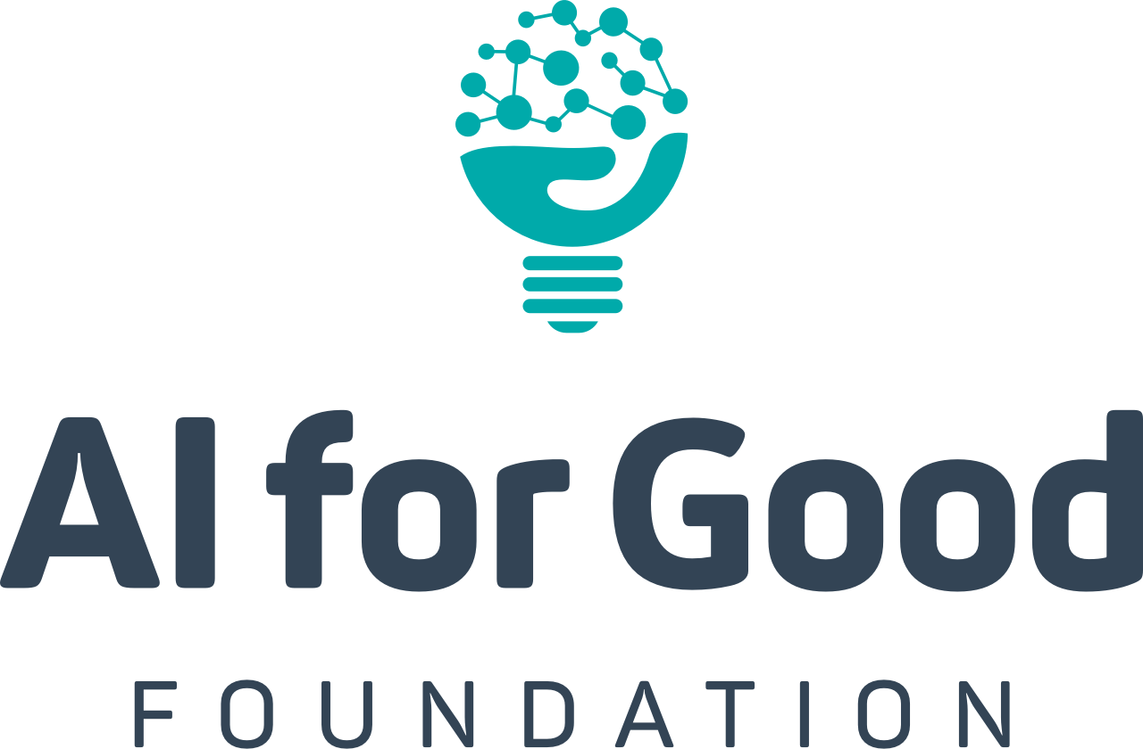

AI + SDG Launchpad
Core Syllabus
1 Semester

Course Overview
The Sustainable Development Goals are the rallying call of our generation. In an enormously complex and interconnected world, we have watched as some of our most fragile ecological structures have been driven to extremes; we have seen only marginal improvements in the delivery of basic literacy and numeracy; universal healthcare is a far-off aspiration, and half of our population participates in society as second class citizens. The acceleration of technology adoption has leveled some playing fields and widened others. Access to technology plays a role in the concentration of wealth and inequality and puts editorial news outlets on a level playing field with advertising networks and propaganda peddlers.
How should technology innovation (and its prodigal child—Artificial Intelligence) be leveraged to support a positive impact on these critical objectives? How do we research, design, debate, plan, and execute interventions that are both human and technological at heart? How do we engender resilient communities with bold plans to make them healthier, happier, and more sustainable? This course seeks to answer these questions

Course Objectives
The purpose of the SDG Launchpad is to act as a foundational curriculum to build the technically sophisticated Policy Scientists of the future—a set of changemakers to operate at all levels of society and around the world to bring the best out of humans and technology for the benefit of society and our planet.
This course consists of modules that include case-based analysis, flipped classrooms, policy development, analytical research, ethical exploration, thought experiments, technical implementation, and a capstone project designed to create real impact. The capstone project will pair students with scientific and domain expert mentors. After the course, alumni are invited to join our Launchpad community, become mentors, get involved in further projects, attend global leadership summits, and participate in crafting the global debate within the AI for Good Foundation.

Prerequisites
We recommend that students have previously completed an introductory CS sequence (minimally, data structures and algorithms), and have completed introductory studies in economics or econometrics. Pure CS or Political Science students have also done well in this class, though these students should prepare for extra time commitments to adapt to the necessary skills of the course. Those who are most successful will have interest, and ideally experience, in all related fields of CS, economics, and policy.

Grading Expectations
Students enrolled in this course will be graded 50% on individual work, and 50% group work.

Student Commitment
Students should expect to invest 6-10 hours per week in the course outside of class time. This course is heavily group project-based, so those who enroll should prepare to commit to their classmates their fullest responsibility. Grades will consist of group work, individual presentations throughout the semester, written assignments reviewed within study groups, and attendance. Once final projects begin, groups should be meeting at least 2x per week to coordinate work on their project, as well as at least 1x per week with their assigned mentor.

Proposed Schedule

Week 1
(Overview Topic 1: Introduction to Course and UN SDGs)
- Lecture 1: Introduction and Course Overview
  - Content: This lecture covers the learning objectives for the course, the prerequisites, and should provide some examples of how Artificial Intelligence has been used within the context of the SDG’s already. Students will also be broken into study groups of 4-5 randomly. These groups will meet each week in order to review the material, discuss any open questions, and present their completed assignments to one another.
- Lecture 2: Structure of the Sustainable Development Goals
  - Content: Overview of the 17 Sustainable Development Goals, and the Millenium Goals that preceded them. The first 10-15 minutes of class to be taken up by 2 randomly selected students presenting their homework assignments.

Week 2
(Overview Topic 5: AI and the Sustainable Development Goals)
- Lecture 1: AI and the Sustainable Development Goals
  - Content: Class will begin with 2 students presenting their previous assignment regarding AI and UN SDGs for 5 minutes each. The lecture is dedicated to relating the Sustainable Development Goals to potential Artificial Intelligence-enabled solutions and supporting infrastructure while keeping in mind all of the areas that have been explored to date in the class.
- Lecture 2: AI + SDG Presentations and Discussion
  - Content: 4-5 students will be randomly selected to present their assignment for 5-10 minutes each, with instructor-facilitated discussion.

Week 3
(Overview Topic 6: Course Project Introduction)
- Lecture 1: Pitching External Projects and Team Assignment
  - Content: External partners with SDG-related problems present for 5 minutes each. If too few external partners are available, or if a supplement is desired, students will use the AI for Good library of open problems and previously tackled problems to foster project ideas. Students assigned into groups of 4-6 randomly to begin their projects.
    - Note: The AI for Good Foundation provides resources to help connect classes to potential partners, and to help them to articulate their SDG-related needs in a way that fits with the class requirements.
- Lecture 2: Presentations of Initial Research Briefs
  - Content: 5-6 groups are chosen randomly to present their assigned initial research brief. Each presentation is followed by an instructor-facilitated debate about the relative strength/impact of the idea. External stakeholders from other departments are invited to view and engage with presentations. This week, instructors and teaching assistants meet with each group to finalise the choice of project and assign either domain mentors or scientific mentors to each team based on the topic and availability. Any team with only a domain mentor will also be paired with a teaching assistant or equivalent scientific point of contact for weekly check-ins.

Week 4
(Overview Topic 2: Research and Science in Society)
- Lecture 1: The Nexus of Policy and Research
  - Content: Who funds research? This lecture will explore how funding sources affect research questions. This class will be case-study-based.
- Lecture 2: Evaluating Science in the Public Domain
  - Content: Lecture on comparing claims made in the media with the underlying scientific evidence. The aim is to take students through a real-world example to show the nuance that exists in interpreting statements of “fact” made even in respectable news outlets with strong editorial processes. Students will also present their previous assignments at the beginning of class.

Week 5
(Overview Topic 3: Indirect Consequences and Adverse Effects)
- Lecture 1: Interrelation of SDGs
  - Content: Students will present their previous assignments on linked claims at the beginning of class. Lecture will consist of evaluating the interrelated nature of Sustainable Development Goals, as well as spillover effects between them. Class will use case studies as the basis for analyzing interrelationships.
- Lecture 2: Presentation and Roundtable of Previous Assignment
  - Content: In this class, 3-4 students are randomly selected to present their assignments and the instructor facilitates class-wide round-table discussions of the topics. At this point, 12-14 students will have been called on to present.

Week 6
(Overview Topic 4: Getting at Causality through Statistical and Econometric Analysis)
- Lecture 1: Causality
  - Content: What does it mean to say that “AI causes jobs to disappear”, or “UBI reduces poverty”, or “smoking causes cancer”, or “leaving the EU will make Britons better off”? This instructor-led lecture will analyze causality and review methodology to support the identification of causal relationships, including Randomised control trials and correlative studies.
- Lecture 2: Presentations of Reports
  - Content: Randomly select 4-5 students to present their previous assignment for 5-10 minutes each, with instructor-facilitated discussion.

Week 7 - MIDTERM
(Overview Topic 8: Presentations of Initial Exploration Documents)
- Lectures 1 and 2: Presentations of Initial Exploration Documents
  - Content: Each group is given 5 minutes to present their initial exploration document research, as reviewed by their assigned mentor. This is followed by 5 minutes of instructor-facilitated discussion.

Week 8
(Overview Topic 7: Ethical Practices for Data)
- Lecture 1: Ethical Practices with Artificial Intelligence
  - Content: This class is intended to be discussion-based. It covers two case studies around the application of an Artificial Intelligence solution that had undesirable spillover effects that systematically affected a protected group more than the average population, using guided discussion questions.
- Lecture 2: Ethical Frameworks in Other Disciplines
  - Content: This class looks at examples of ethical frameworks drawn from other disciplines (doctors, engineers, and lawyers). The class is group activity-based, and students will explore potential ethical considerations and frameworks for the AI researcher and implementation community. 2-3 students are selected to present their previous homework assignment, followed by instructor-facilitated discussion. .
- Project Deliverable: Core data collection and system design (storage, databases, infrastructure components, UX considerations, deployment plan)

Week 9 and 10
(Overview Additional Topic A: Evaluating Machine Learning Models Effectively- Double Length)
- These classes aim to provide students with a basic framework for thinking about the “performance” of Machine Learning models in practice. Topics include Data Selection and Auditing, Traditional Data Training Methods, Errors and Statistical Significance, Evaluation and Updating of Models, Acceptability of Results, and Interpretability Trade-Offs.
- Week 9 Project Deliverable: Machine Learning development plan
- Week 10 Project Deliverable: Modelling, Infrastructure Development

Week 11
(Overview Topic D: AI and Policy in Practice: Designing Policy Interventions)
- This class explores how governments and NGOs go about the policy design and implementation process, and key issues with the implementation of AI-supported interventions. We consider elements such as stakeholder processes, auditing of technology infrastructure and security, how/where should infrastructure be deployed, and how policy interventions can be appropriately evaluated relative to non-AI interventions.
- Project Deliverable: Proof of concept deployment plan (recruiting a test population)

Week 12
(Overview Topic G: Perceptions of AI in Society)
- This class explores the communication and perceptions of AI in society, from news media, to governments, prominent individuals, companies, scientists, and movies. This module leverages resources connected to the AI for Good Foundation’s Global Perceptions of AI Survey.
- Project Deliverable: Evaluation and Project Report
Final Week: Final Presentations to stakeholders, and submission of project packet with all resources.

